Hoylaerts Noah GRP-B

Q1) Les 20ers athlètes avec le plus de participation aux JO sont : 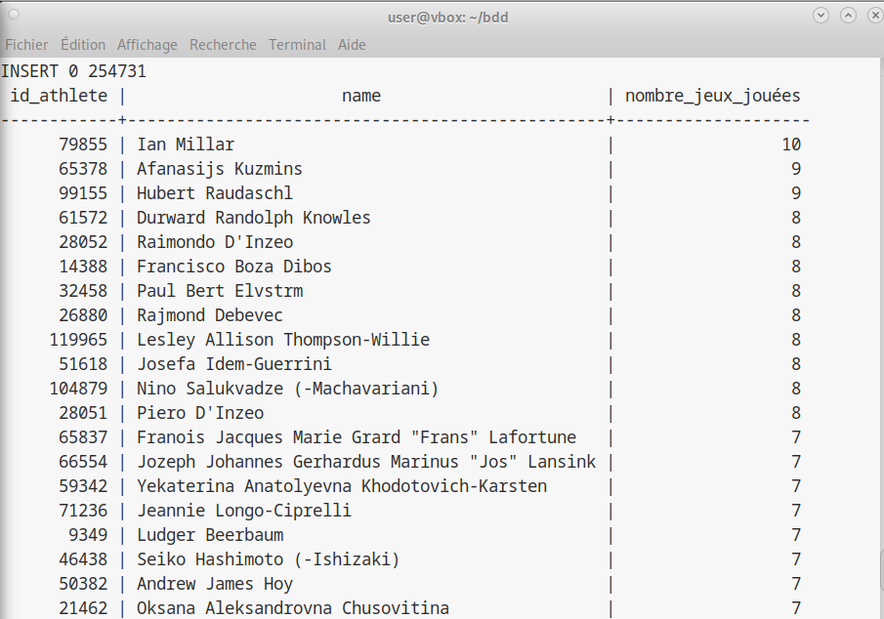Ces résultats ont été obtenues via la requête suivante :

SELECT id_athlete, athlete.name ,COUNT(DISTINCT id_game) AS nombre_jeux_jouées

FROM performance, athlete

WHERE athlete.id = performance.id_athlete

GROUP BY id_athlete, athlete.name

ORDER BY nombre_jeux_jouées DESC

LIMIT 20;

Q2) L’année que j’ai choisie est 1964 avec les jeux d’été.

|  |  |  |  |  |
| --- | --- | --- | --- | --- |
| Pays | Moyenne d’âge | Nb sportifs | Min âge | Max âge |
| Argentina | 27.36 | 22 | 16 | 53 |
| Australia | 22.93 | 14 | 17 | 31 |
| Austria | 24.24 | 116 | 15 | 47 |
| Belgium | 24.64 | 11 | 20 | 31 |
| Bulgaria | 26.11 | 19 | 20 | 30 |
| Canada | 24.66 | 95 | 16 | 38 |
| Chile | 22.18 | 11 | 20 | 27 |
| Czech Republic | 23.87 | 69 | 13 | 33 |
| Denmark | 27.40 | 5 | 25 | 29 |
| Finland | 25.15 | 87 | 18 | 39 |
| France | 23.06 | 50 | 16 | 33 |
| Germany | 24.27 | 144 | 15 | 43 |
| Greece | 22.71 | 7 | 21 | 24 |
| Hungary | 23.45 | 42 | 13 | 33 |
| Iceland | 23.00 | 10 | 19 | 28 |
| India | 24.00 | 1 | 24 | 24 |
| Iran | 25.33 | 12 | 24 | 27 |
| Italy | 25.41 | 93 | 15 | 36 |
| Japan | 23.64 | 85 | 17 | 30 |
| Lebanon | 22.00 | 12 | 22 | 22 |
| Liechtenstein | 18.25 | 12 | 14 | 24 |
| Mongolia | 23.64 | 22 | 18 | 29 |
| Netherlands | 21.17 | 12 | 19 | 23 |
| North Korea | 21.60 | 20 | 18 | 30 |
| Norway | 24.06 | 90 | 16 | 35 |
| Poland | 25.64 | 86 | 18 | 35 |
| Romania | 24.83 | 31 | 18 | 31 |
| Russia | 25.95 | 107 | 18 | 34 |
| Serbia | 23.33 | 54 | 18 | 30 |
| South Korea | 23.25 | 16 | 17 | 30 |
| Spain | 21.33 | 12 | 18 | 23 |
| Sweden | 25.76 | 103 | 17 | 47 |
| Switzerland | 24.34 | 104 | 18 | 41 |
| Turkey | 28.00 | 12 | 21 | 34 |
| UK | 23.75 | 65 | 17 | 34 |
| USA | 24.09 | 127 | 14 | 41 |

J’ai pu obtenir le tableau avec la requête suivante :

select noc.region, avg(age), count(id_athlete), min(age), max(age)

from performance, game, noc

where performance.id_game = game.id and performance.noc = noc.noc and game.season like '%Winter' and game.year = 1964

GROUP BY noc.region;

Q2.2) L'âge moyen des médaillés est de 25.53 contre 24.42 pour les candidats  
On peut donc voir que les médaillés sont légèrement plus vieux que les non-médaillés

select round(avg(age),2) as AVGeveryone

FROM performance, game, noc

where performance.id_game = game.id and performance.noc = noc.noc and game.season like '%Winter' and game.year = 1964

group by game.year;

-- medal

select round(avg(age),2) as medal

FROM performance, game, noc

where performance.id_game = game.id and performance.noc = noc.noc and game.season like '%Winter' and game.year = 1964 and performance.medal in ('Gold','Silver','Bronze')

group by game.year;

Q2.3)

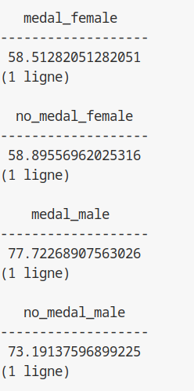

Comme nous pouvons le voir sur l’image ci-dessus, l’écart entre les femmes médaillées et non-médaillés n’est que de 300g

En comparaison, cet écart s’intensifie entre les hommes médaillés et non-médaillés avec environ 4Kg500

On peut donc en déduire que l’écart de poids n’est que peu important chez les femmes comparées aux hommes

Par ailleurs ces kilogrammes peuvent signifier une plus grosse masse musculaire chez les hommes ce qui expliqueraient pourquoi les hommes médaillés sont plus lourds.

Les requêtes sont les suivantes :

select avg(weight) as medal_female

FROM performance, game, noc, athlete

where performance.id_game = game.id and performance.noc = noc.noc and game.season like '%Winter' and game.year = 1964 and performance.medal in ('Gold','Silver','Bronze') and performance.id_athlete = athlete.id and sex = 'F'

group by game.year;

-- No Medal

select avg(weight) as no_medal_female

FROM performance, game, noc, athlete

where performance.id_game = game.id and performance.noc = noc.noc and game.season like '%Winter' and game.year = 1964 and performance.id_athlete = athlete.id and sex = 'F'

group by game.year;

-- Male

-- Medal

select avg(weight) as medal_male

FROM performance, game, noc, athlete

where performance.id_game = game.id and performance.noc = noc.noc and game.season like '%Winter' and game.year = 1964 and performance.medal in ('Gold','Silver','Bronze') and performance.id_athlete = athlete.id and sex = 'M'

group by game.year;

-- No Medal

select avg(weight) as no_medal_male

FROM performance, game, noc, athlete

where performance.id_game = game.id and performance.noc = noc.noc and game.season like '%Winter' and game.year = 1964 and performance.id_athlete = athlete.id and sex = 'M'

group by game.year;

Q3.1)

Les 15ers pays à avoir obtenues le plus de médailles entre 1992 et 2016 sont :

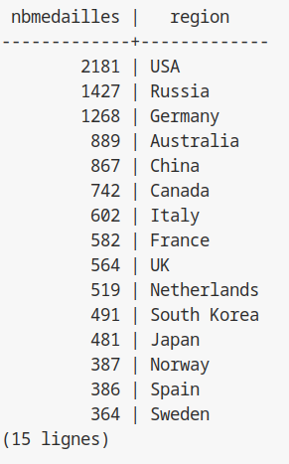

La requête qui m’a permis d’avoir ce résultat est :

SELECT COUNT(*) AS nbMedailles, noc.region

FROM performance, game, noc

where performance.id_game = game.id and performance.noc = noc.noc and game.year between 1992 and 2016 and performance.medal in ('Gold','Silver','Bronze')

GROUP BY noc.region

order by nbMedailles DESC

limit 15;

D’après les résultats obtenus, j’ai décidé de choisir le japon, la Chine, la Corée du nord, les Pays-Bas et la Suède.

Q3.2.1)

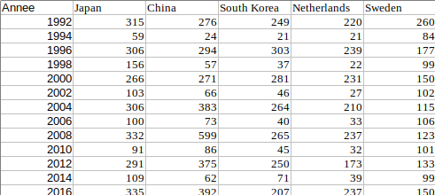

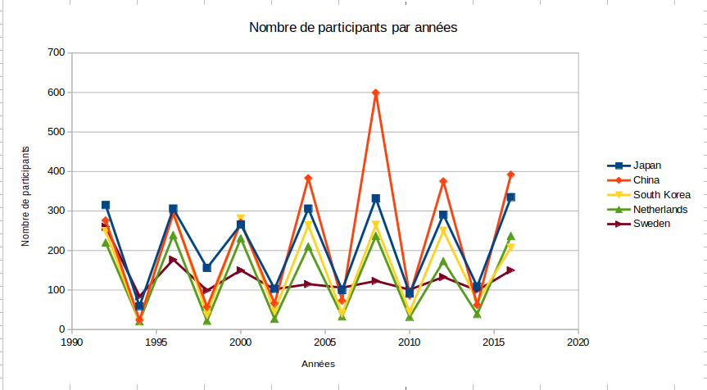Comme nous pouvons le voir sur ce graphique, la Chine as le plus de participant depuis 2004, le classement était avant dominé par le japon. On peut aussi voir que le nombre de participants à tendance à stagné depuis 2004

select count(DISTINCT id_athlete) as japan, game.year

FROM performance, game, noc

where performance.id_game = game.id and performance.noc = noc.noc and game.year between 1992 and 2016 and performance.noc = 'JPN'

group by game.year;

select count(DISTINCT id_athlete) as china

FROM performance, game, noc

where performance.id_game = game.id and performance.noc = noc.noc and game.year between 1992 and 2016 and performance.noc = 'CHN'

group by game.year;

select count(DISTINCT id_athlete) as south_korea

FROM performance, game, noc

where performance.id_game = game.id and performance.noc = noc.noc and game.year between 1992 and 2016 and performance.noc = 'KOR'

group by game.year;

select count(DISTINCT id_athlete) as netherlands

FROM performance, game, noc

where performance.id_game = game.id and performance.noc = noc.noc and game.year between 1992 and 2016 and performance.noc = 'NED'

group by game.year;

select count(DISTINCT id_athlete) as Sweden

FROM performance, game, noc

where performance.id_game = game.id and performance.noc = noc.noc and game.year between 1992 and 2016 and performance.noc = 'SWE'

group by game.year;

Q3.2.2)

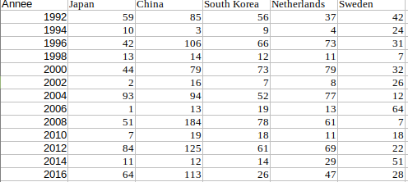

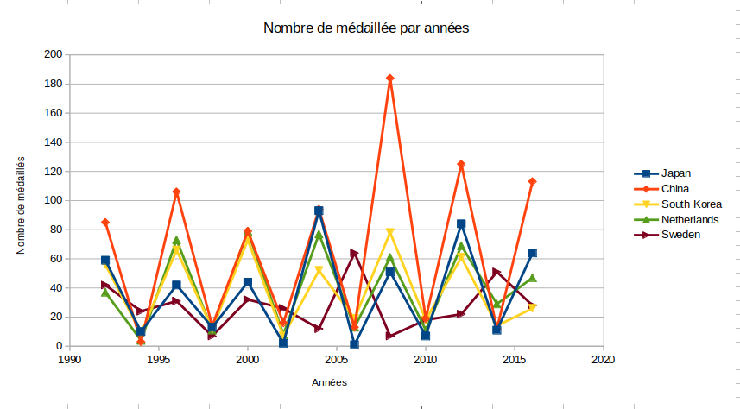Comme on peut le voir, la Chine a quasiment toujours dominé le classement avec un pic en 2008, qui peut être expliqué par le nombre de participants record cette année-là.

select count(*) as japan

FROM performance, game, noc

where performance.id_game = game.id and performance.noc = noc.noc and game.year between 1992 and 2016 and performance.noc = 'JPN' and medal not in ('NA')

group by game.year;

select count(*) as china

FROM performance, game, noc

where performance.id_game = game.id and performance.noc = noc.noc and game.year between 1992 and 2016 and performance.noc = 'CHN' and medal not in ('NA')

group by game.year;

select count(*) as south_korea

FROM performance, game, noc

where performance.id_game = game.id and performance.noc = noc.noc and game.year between 1992 and 2016 and performance.noc = 'KOR' and medal not in ('NA')

group by game.year;

select count(*) as netherlands

FROM performance, game, noc

where performance.id_game = game.id and performance.noc = noc.noc and game.year between 1992 and 2016 and performance.noc = 'NED' and medal not in ('NA')

group by game.year;

select count(*) as Sweden

FROM performance, game, noc

where performance.id_game = game.id and performance.noc = noc.noc and game.year between 1992 and 2016 and performance.noc = 'SWE' and medal not in ('NA')

group by game.year;

Q3.2.3)

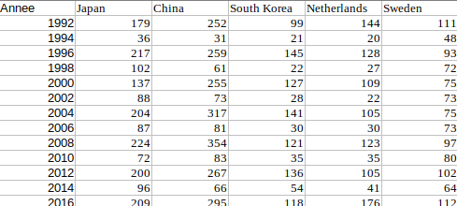

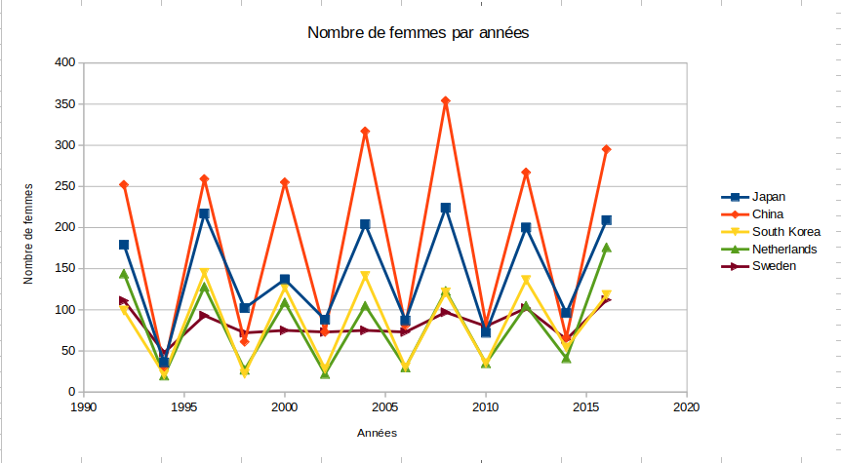Comme nous pouvons le voir, la Chine a toujours eu plus de femmes dans ses rangs. De plus, dans certains pays, aucune évolution n’est à constater depuis 1996.

select count(*) as japan

FROM performance, game, noc, athlete

where performance.id_game = game.id and performance.noc = noc.noc and game.year between 1992 and 2016 and performance.noc = 'JPN' and performance.id_athlete = athlete.id and sex = 'F'

group by game.year;

select count(*) as china

FROM performance, game, noc, athlete

where performance.id_game = game.id and performance.noc = noc.noc and game.year between 1992 and 2016 and performance.noc = 'CHN' and performance.id_athlete = athlete.id and sex = 'F'

group by game.year;

select count(*) as south_korea

FROM performance, game, noc, athlete

where performance.id_game = game.id and performance.noc = noc.noc and game.year between 1992 and 2016 and performance.noc = 'KOR' and performance.id_athlete = athlete.id and sex = 'F'

group by game.year;

select count(*) as netherlands

FROM performance, game, noc, athlete

where performance.id_game = game.id and performance.noc = noc.noc and game.year between 1992 and 2016 and performance.noc = 'NED' and performance.id_athlete = athlete.id and sex = 'F'

group by game.year;

select count(*) as Sweden

FROM performance, game, noc, athlete

where performance.id_game = game.id and performance.noc = noc.noc and game.year between 1992 and 2016 and performance.noc = 'SWE' and performance.id_athlete = athlete.id and sex = 'F'

group by game.year;

Q3.2.4)

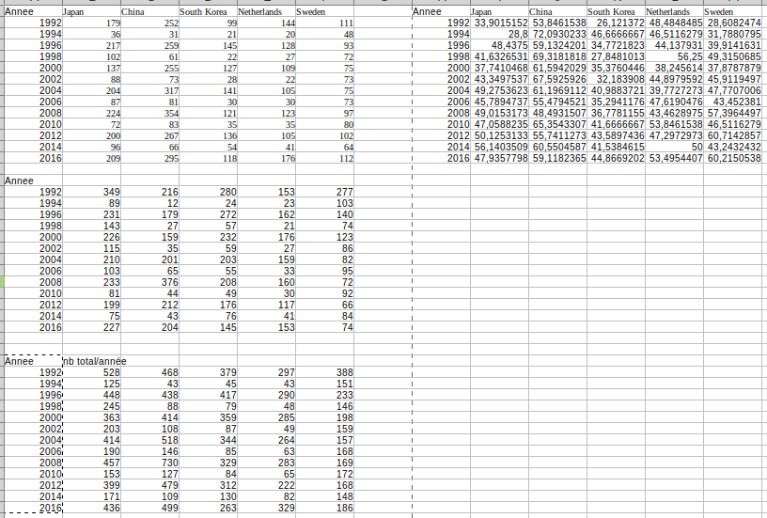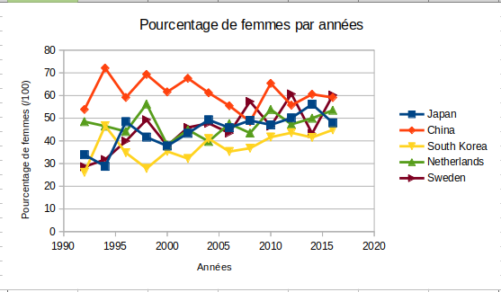

Nous pouvons voir grâce aux graphiques ci-dessus que le pourcentage de femmes à tendance a augmenté surtout au japon et en suède. On notera encore une fois que la Chine a le plus grand pourcentage de femmes depuis longtemps mais s’est fait dépasser par la suède récemment.

Pour trouver ces résultats, j’ai calculé le nombre de femmes à la question précédentes puis le nombres d’homme pour ensuite faire le total, grâce à LibreOffice Calc, j’ai ensuite utilisé la formule suivante “=(B<Année femme>*100)/B<Année total>”

select count(*) as japan

FROM performance, game, noc, athlete

where performance.id_game = game.id and performance.noc = noc.noc and game.year between 1992 and 2016 and performance.noc = 'JPN' and performance.id_athlete = athlete.id and sex = 'M'

group by game.year;

select count(*) as china

FROM performance, game, noc, athlete

where performance.id_game = game.id and performance.noc = noc.noc and game.year between 1992 and 2016 and performance.noc = 'CHN' and performance.id_athlete = athlete.id and sex = 'M'

group by game.year;

select count(*) as south_korea

FROM performance, game, noc, athlete

where performance.id_game = game.id and performance.noc = noc.noc and game.year between 1992 and 2016 and performance.noc = 'KOR' and performance.id_athlete = athlete.id and sex = 'M'

group by game.year;

select count(*) as netherlands

FROM performance, game, noc, athlete

where performance.id_game = game.id and performance.noc = noc.noc and game.year between 1992 and 2016 and performance.noc = 'NED' and performance.id_athlete = athlete.id and sex = 'M'

group by game.year;

select count(*) as Sweden

FROM performance, game, noc, athlete

where performance.id_game = game.id and performance.noc = noc.noc and game.year between 1992 and 2016 and performance.noc = 'SWE' and performance.id_athlete = athlete.id and sex = 'M'

group by game.year;

Q3.2.5

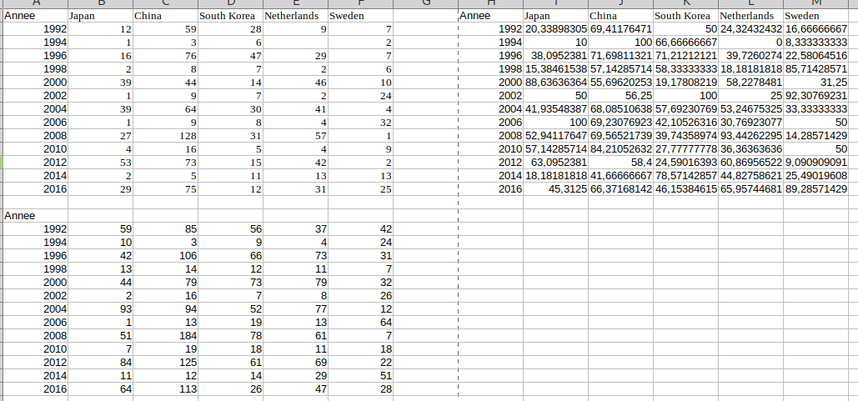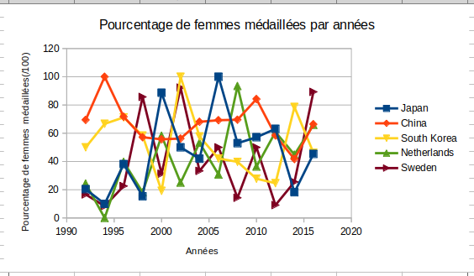

Comme nous pouvons le voir sur ce graphique, le pourcentage de femme remportant des médailles est de plus en plus élevé, partant de –20% au japon a 100% en 2006 avant de redescendre

On peut donc dire que les femmes jouent un rôle toujours plus important et égalitaire dans les J.O, même si ce n’est pas toujours une égalité parfaite.

Pour trouver les données j’ai fait le nombre de femme médaillés/ le nombre de médailles total *100 pour avoir un pourcentage soit =B<>Année nombre femme médaillés/B<Années nombre total de médailles>*100

- NbFemme

select count(*) as japan_NbFemme

FROM performance, game, noc, athlete

where performance.id_game = game.id and performance.noc = noc.noc and game.year between 1992 and 2016 and performance.noc = 'JPN' and medal not in ('NA') and performance.id_athlete = athlete.id and sex = 'F'

group by game.year;

select count(*) as china

FROM performance, game, noc, athlete

where performance.id_game = game.id and performance.noc = noc.noc and game.year between 1992 and 2016 and performance.noc = 'CHN' and medal not in ('NA') and performance.id_athlete = athlete.id and sex = 'F'

group by game.year;

select count(*) as south_korea

FROM performance, game, noc, athlete

where performance.id_game = game.id and performance.noc = noc.noc and game.year between 1992 and 2016 and performance.noc = 'KOR' and medal not in ('NA') and performance.id_athlete = athlete.id and sex = 'F'

group by game.year;

select count(*) as netherlands, game.year

FROM performance, game, noc, athlete

where performance.id_game = game.id and performance.noc = noc.noc and game.year between 1992 and 2016 and performance.noc = 'NED' and medal not in ('NA') and performance.id_athlete = athlete.id and sex = 'F'

group by game.year;

select count(*) as Sweden

FROM performance, game, noc, athlete

where performance.id_game = game.id and performance.noc = noc.noc and game.year between 1992 and 2016 and performance.noc = 'SWE' and medal not in ('NA') and performance.id_athlete = athlete.id and sex = 'F'

group by game.year;

--Nbmedal

select count(*) as japan

FROM performance, game, noc

where performance.id_game = game.id and performance.noc = noc.noc and game.year between 1992 and 2016 and performance.noc = 'JPN' and medal not in ('NA')

group by game.year;

select count(*) as china

FROM performance, game, noc

where performance.id_game = game.id and performance.noc = noc.noc and game.year between 1992 and 2016 and performance.noc = 'CHN' and medal not in ('NA')

group by game.year;

select count(*) as south_korea

FROM performance, game, noc

where performance.id_game = game.id and performance.noc = noc.noc and game.year between 1992 and 2016 and performance.noc = 'KOR' and medal not in ('NA')

group by game.year;

select count(*) as netherlands, game.year

FROM performance, game, noc

where performance.id_game = game.id and performance.noc = noc.noc and game.year between 1992 and 2016 and performance.noc = 'NED' and medal not in ('NA')

group by game.year;

select count(*) as Sweden

FROM performance, game, noc

where performance.id_game = game.id and performance.noc = noc.noc and game.year between 1992 and 2016 and performance.noc = 'SWE' and medal not in ('NA')

group by game.year;

Q3.2.6)

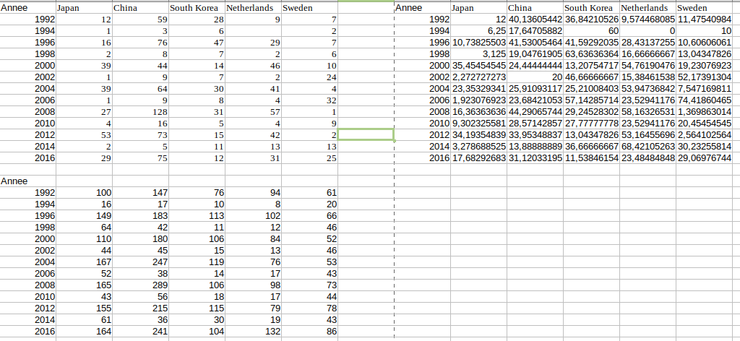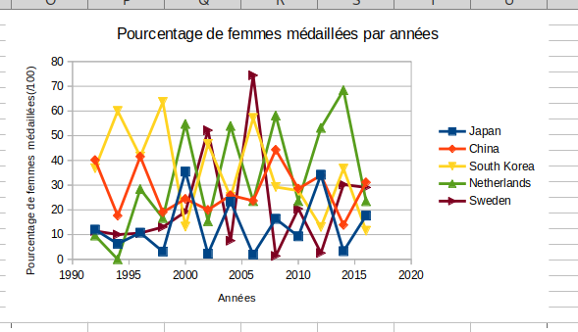

Comme nous pouvons le voir sur ce graphique ci-dessus, il y a de plus en plus de femmes qui sont médaillés parmi les femmes qui y participent. Notamment au Pays-Bas malgré une chute régulière une participation sur 2. On peut également citer le japon non pas pour son augmentation fulgurante mais par le fait que les femmes sont de plus en plus ouvertes et acceptés dans le sport. Cependant, on notera que la chine, malgré beaucoup de participation féminine, peu d’entre elles sont médaillés, cela peut s’expliquer par un grand nombre de participantes ou une société dans lequel le sport chez la femme est mal vu ce qui entraine de mauvaise condition physique.  
Pour trouver ces données, j’ai calculé le nombre de femmes médaillés comme sur la requête précédente puis le nombre de femme participantes, enfin j’ai utilisé la formule NbFemmeMédaillés/NbFemmes ou sur LibreOffice Calc la formule =B<Année nombre femme médaillés>/B<Années nombre total de médailles>*100

--NbFemmeMedal

select count(*) as japan_NbFemmeMedal

FROM performance, game, noc, athlete

where performance.id_game = game.id and performance.noc = noc.noc and game.year between 1992 and 2016 and performance.noc = 'JPN' and medal not in ('NA') and performance.id_athlete = athlete.id and sex = 'F'

group by game.year;

select count(*) as china

FROM performance, game, noc, athlete

where performance.id_game = game.id and performance.noc = noc.noc and game.year between 1992 and 2016 and performance.noc = 'CHN' and medal not in ('NA') and performance.id_athlete = athlete.id and sex = 'F'

group by game.year;

select count(*) as south_korea

FROM performance, game, noc, athlete

where performance.id_game = game.id and performance.noc = noc.noc and game.year between 1992 and 2016 and performance.noc = 'KOR' and medal not in ('NA') and performance.id_athlete = athlete.id and sex = 'F'

group by game.year;

select count(*) as netherlands, game.year

FROM performance, game, noc, athlete

where performance.id_game = game.id and performance.noc = noc.noc and game.year between 1992 and 2016 and performance.noc = 'NED' and medal not in ('NA') and performance.id_athlete = athlete.id and sex = 'F'

group by game.year;

select count(*) as Sweden

FROM performance, game, noc, athlete

where performance.id_game = game.id and performance.noc = noc.noc and game.year between 1992 and 2016 and performance.noc = 'SWE' and medal not in ('NA') and performance.id_athlete = athlete.id and sex = 'F'

group by game.year;

--NbFemme

select count(DISTINCT id_athlete) as japan

FROM performance, game, noc, athlete

where performance.id_game = game.id and performance.noc = noc.noc and game.year between 1992 and 2016 and performance.noc = 'JPN' and performance.id_athlete = athlete.id and sex = 'F'

group by game.year;

select count(DISTINCT id_athlete) as china

FROM performance, game, noc, athlete

where performance.id_game = game.id and performance.noc = noc.noc and game.year between 1992 and 2016 and performance.noc = 'CHN'and performance.id_athlete = athlete.id and sex = 'F'

group by game.year;

select count(DISTINCT id_athlete) as south_korea

FROM performance, game, noc, athlete

where performance.id_game = game.id and performance.noc = noc.noc and game.year between 1992 and 2016 and performance.noc = 'KOR' and performance.id_athlete = athlete.id and sex = 'F'

group by game.year;

select count(DISTINCT id_athlete) as netherlands

FROM performance, game, noc, athlete

where performance.id_game = game.id and performance.noc = noc.noc and game.year between 1992 and 2016 and performance.noc = 'NED' and performance.id_athlete = athlete.id and sex = 'F'

group by game.year;

select count(DISTINCT id_athlete) as Sweden

FROM performance, game, noc, athlete

where performance.id_game = game.id and performance.noc = noc.noc and game.year between 1992 and 2016 and performance.noc = 'SWE' and performance.id_athlete = athlete.id and sex = 'F'

group by game.year;